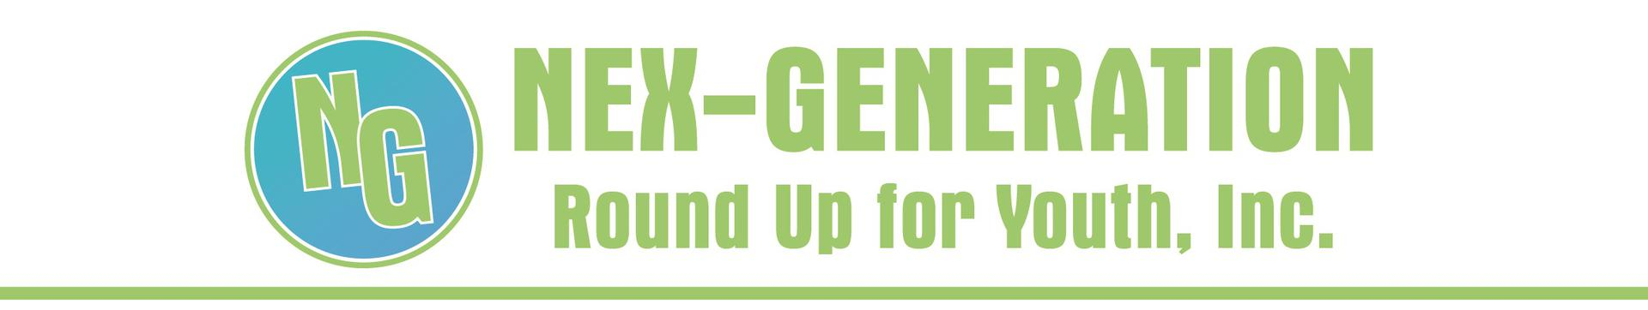
Nex-Gen News - August 11, 2020
2020 Summer Internships Huge Success
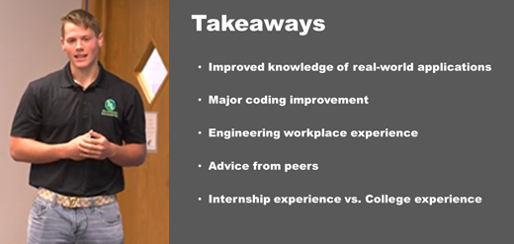
What a fantastic summer for our Nex-Gen interns! Despite a crazy year, more than 70 northwest and north central Kansas businesses provided hands-on learning opportunities for 87 high school and college students.

Local kids learning from local professionals.

Arie Olson of Atwood (pictured above) is entering his sophomore year at K-State this fall. An engineering major, he wanted to find an internship as a freshman, but found it was difficult to do, unless you were a college junior or senior - that is, until he found the Nex-Generation Student Internship Program and landed a 9-week, paid, summer internship with SureFire Ag Systems in his hometown of Atwood!
Listen to Arie's testimonial by clicking HERE.

Through the Nex-Generation Student Internship Program, high school and college students like Arie are developing hands-on job skills; learning about business and entrepreneurship; learning about their hometown and surrounding communities; and gaining wisdom and professionalism through mentorship and community engagement.

They are making decisions about their futures.

Thank you for helping us take these students
FROM THE CLASSROOM TO A CAREER!

Want to be a part of this amazing program?
Business applications for 2021 are due August 15.
BUSINESSES APPLY ONLINE TODAY!

Interns Attend Leadership Day
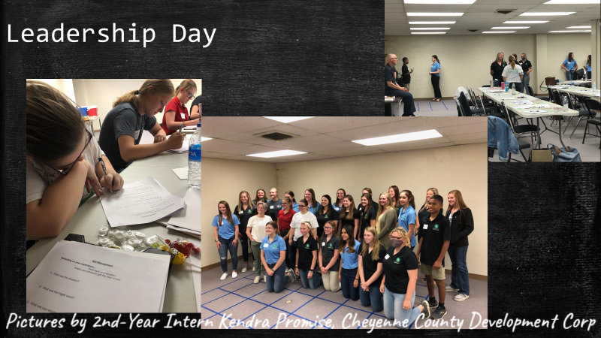
Phillips County Strategic Doing/Young Professionals Work Group hosted Nex-Generation interns on June 26 for a "Leadership Day." Kansas Representative Ken Rahjes, 110th District, provided opening remarks, encouraging students to look to their local communities for career opportunities. Myndi Krafft with Leadership Kansas provided a fun and engaging program on Emotional Intelligence, and a panel of four, local, business professionals shared their personal stories about staying in their home community or having returned back. "I want to thank [Nex-Gen and Phillips County] for doing the Intern Leadership Day. It was so much fun and I learned a lot. And thank you for supplying us with the Emotional Intelligence 2.0 book," Adrienne Selzer, Fort Wallace Museum intern.
Proven Track Record
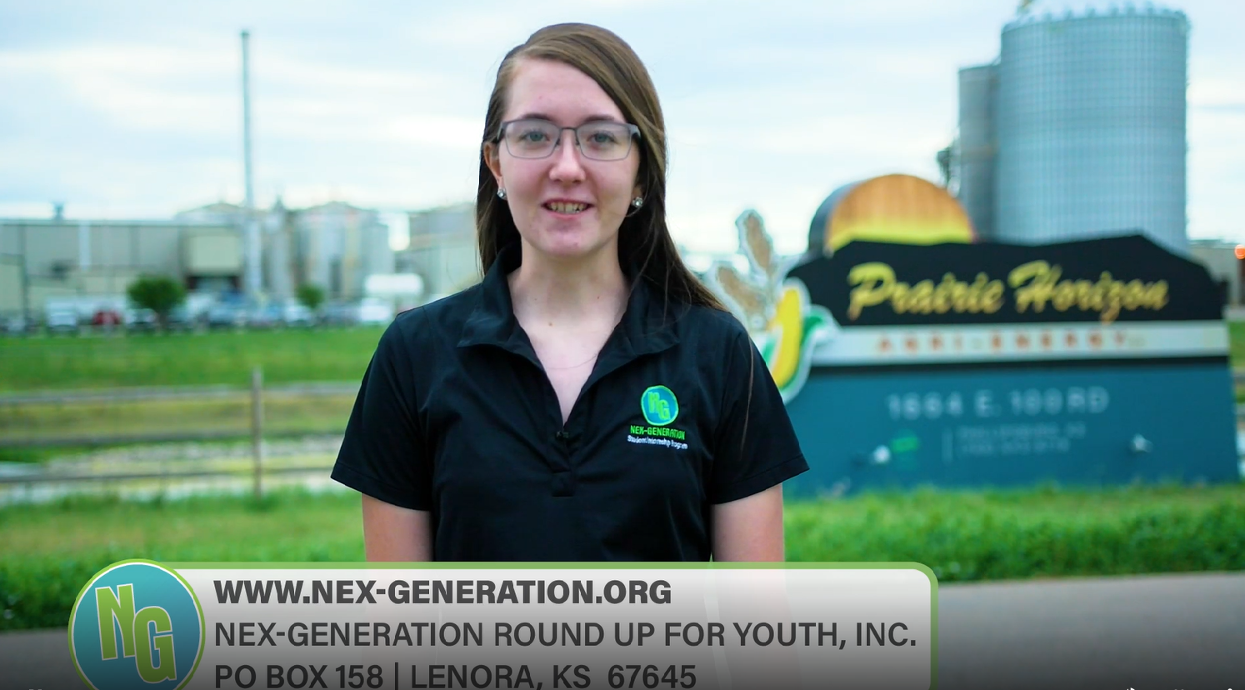
Karlee Braun is a 4th-year Nex-Gen intern with Prairie Horizon Agri Energy, LLC, in Phillipsburg. "What I really like about Karlee is how she has grown with this program," states Mendi Anschutz, Nex-Gen's PR/Marketing Director. "When a student stays in the program multiple years, it's truly amazing to watch them grow, mature, and start to identify with whom they are, both personally and professionally. Karlee is no exception and is an amazing individual."

Her mentor at Prairie Horizon agrees: "Karlee learned a few new areas of our business that she had not previously. While she knew almost everything from past years, this summer she was able to take care of grain truck freight payments. It was great seeing her come in this year, less shy, and being able to pick up where she left off last summer. Didn’t hesitate with anything at any time. She's detail oriented and a great trainer, having trained a full-time employee before she left (and others last year). She will be a great asset wherever she goes in the future. She has been amazing."

Here is Karlee's internship story.

IMPACT...
Your support makes a difference!
As a 501(c)(3), non-profit organization, Nex-Gen relies on the financial support of donors like you.

Since 2011, more than 260 students have participated as Nex-Gen interns and work studies. Thanks to you, we have reinvested nearly $690,000 back into the local economy through intern wages and work study scholarships. Thanks to you, more students continue to experience local jobs with local employers, right here in northwest and north central Kansas!
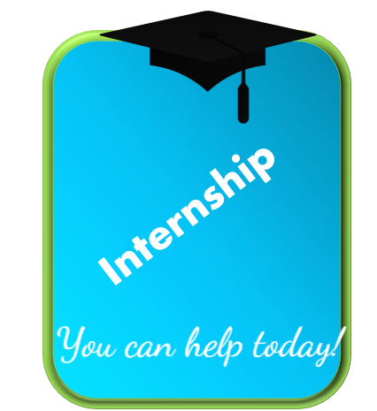
DONATE TODAY
Thank you for helping us take students
"FROM THE CLASSROOM TO A CAREER!"
Our Contact Information
Nex-Generation Round Up for Youth, Inc.
PO Box 158, 145 N. Main
Lenora, KS 67645
877-567-7872
www.nex-generation.org

